Kubernetes Task-2

Task Description:

Create the K8s EKS,further you have to do the deployment of the Nginx application and access the application outside the cluster.

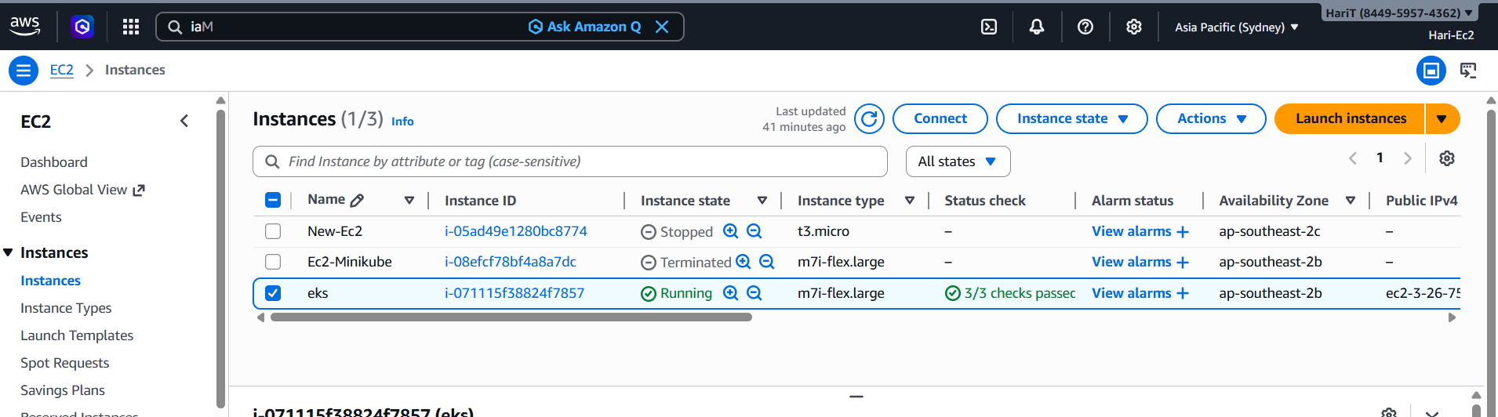

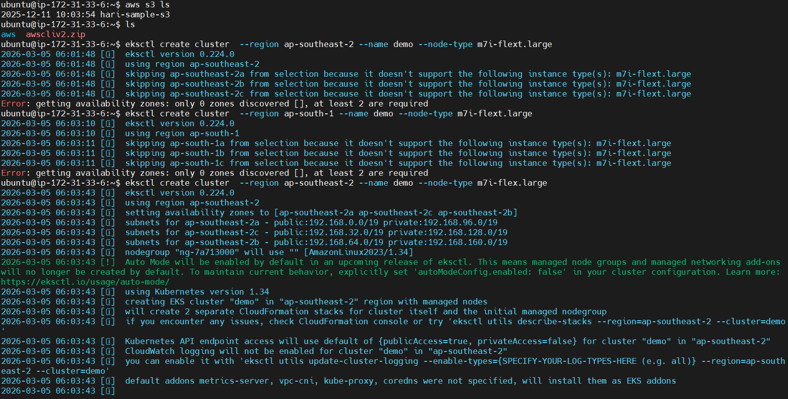
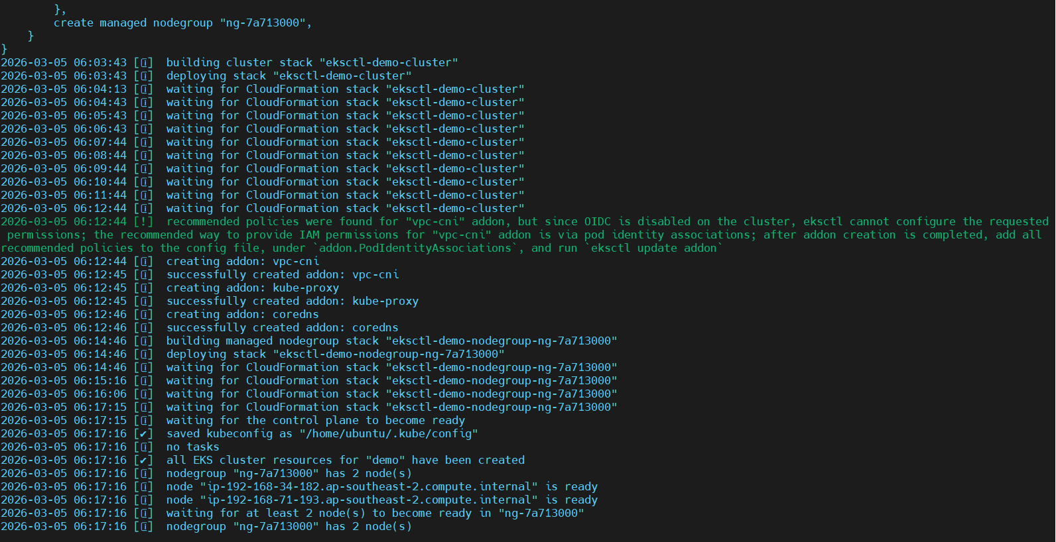

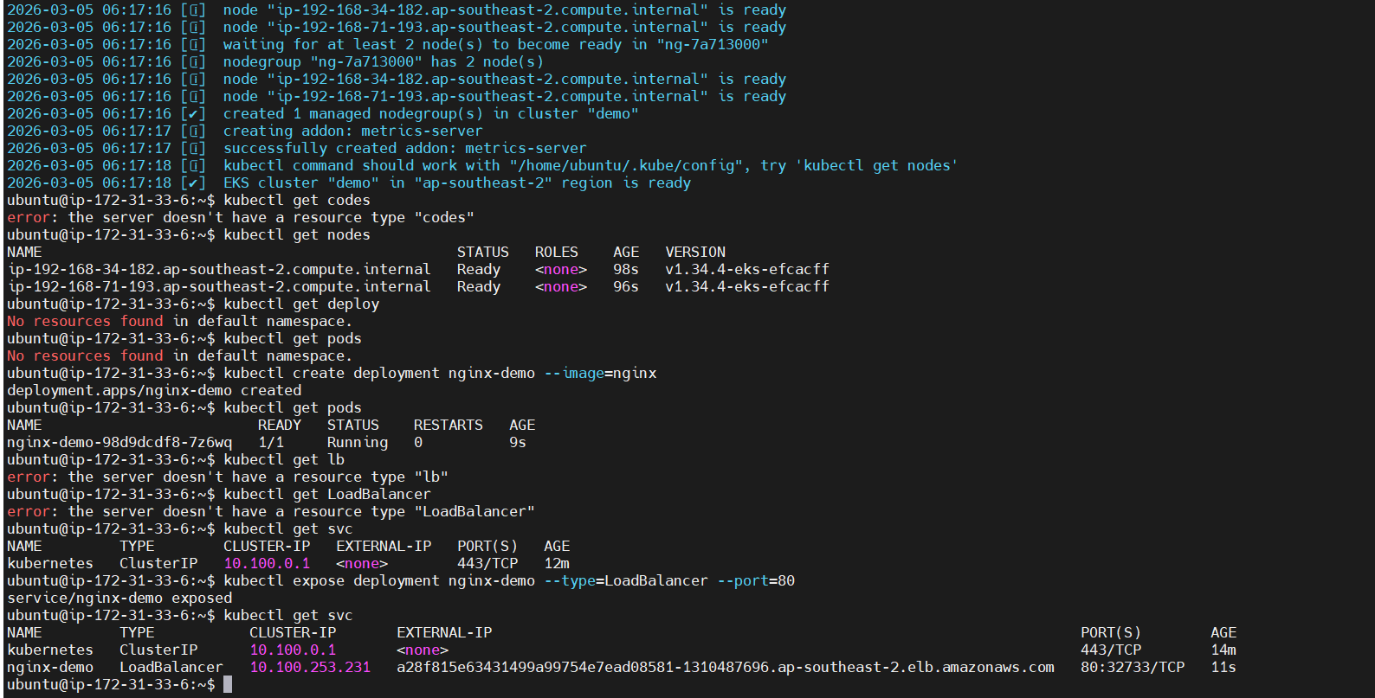

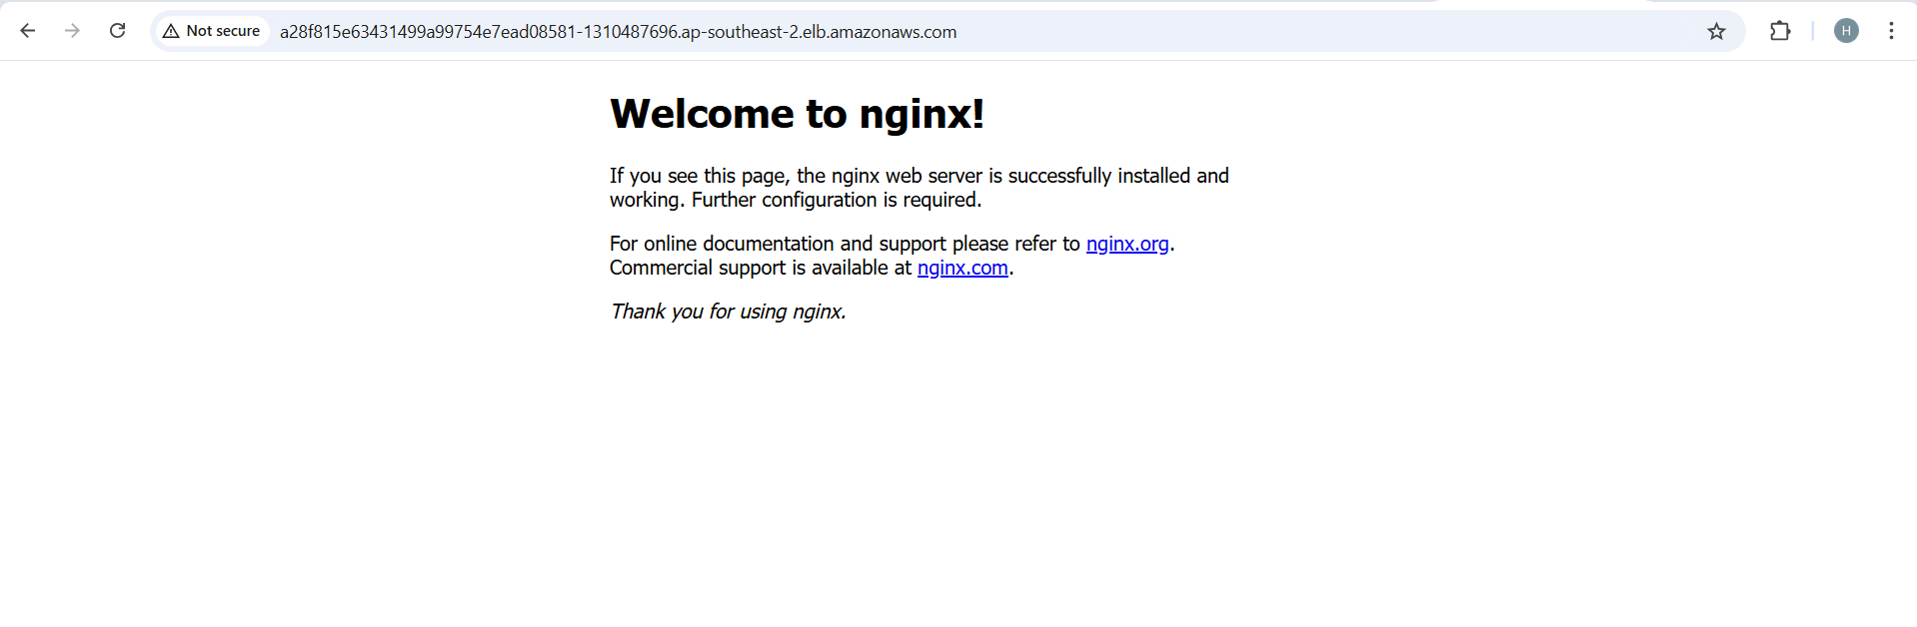
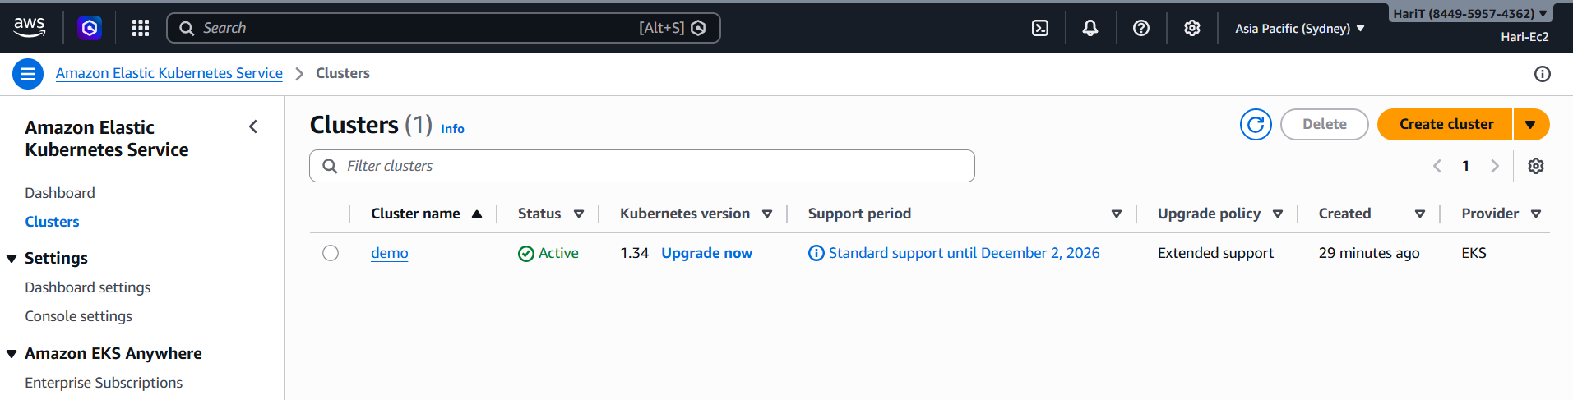

After executed cleared the cluster
